RBT211 – Final Project (Tree Light)
Joe Parisia

For my final in RBT211 I have decided that I will be using an ATMEGA328p chip to control two LEDs and a button. For this project to work I will be using the Port Manipulation techniques learned early on in the class to create a program in Atmel Studio. Once the code is finished I will be using a USBasp Programmer to upload the code to my chip and have a working program.
The purpose of this project is to help those who live at my house let each other know if the tree in our backyard has been watered. Having multiple people in the house can sometimes make it impossible to know if someone has already watered it, forgot to water it, or if it needs watering. The goal is to have a RED light lit when the tree needs to be watered. Once somebody waters the plant they will push the button and the GREEN LED will light up for 24 hours letting everyone know that it has been done within the last day. My approach for coding is pretty straight forward. I will be using an If statement to check if the button was pressed. If the button was pressed the ATMEGA328p lights up the Green LED for a time determined by the delay. In this case It will be ~8 million milliseconds before the GRN LED turns off. If the button wasn’t pressed (else statement) then the RED LED will be lit.
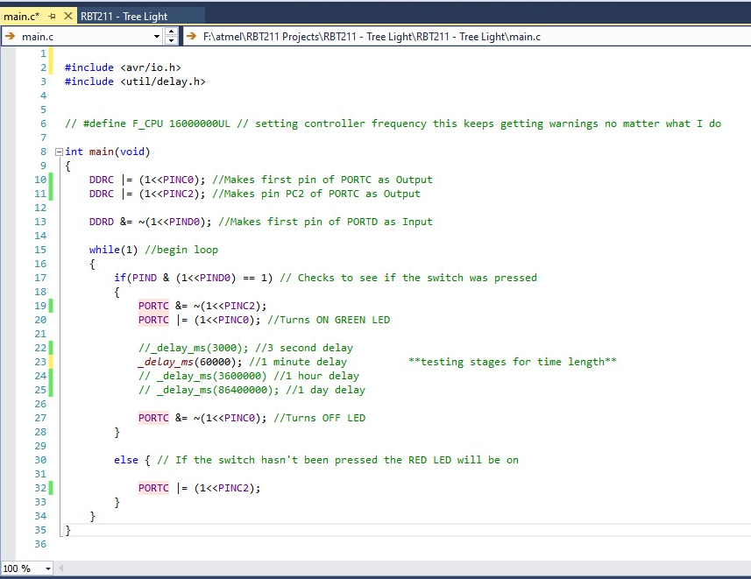
As you can see the code was very simple but does its job. The code has been commented heavily to show what each step is doing. Below you will see the wiring diagram for this circuit.

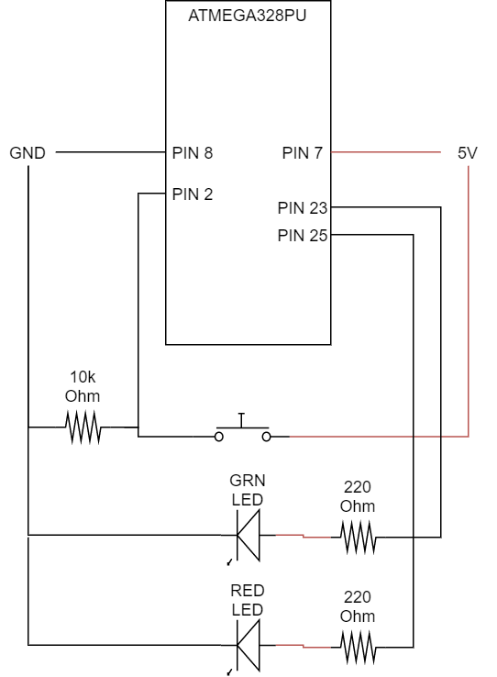

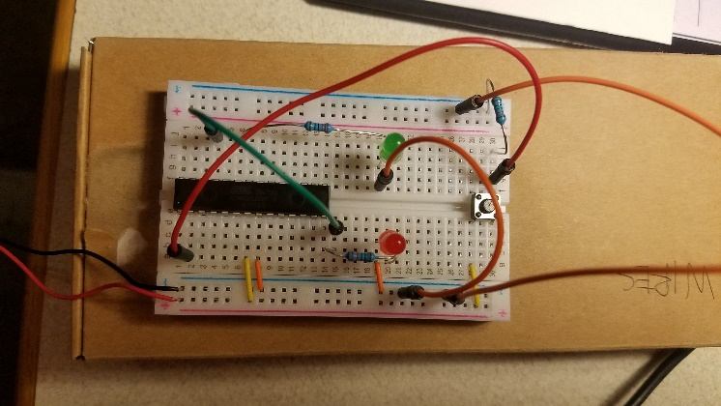
The materials required for this were as follows:
- ATMEGA328p
- 2 - LED (1 GRN, 1 RED)
- 2 – 220 Ohm resistor
- 10k Ohm Resistor
- Pushbutton
- Power supply (5V)

And Voila! Here is a brief explanation / demo of my working program / circuit. If above video doesn’t work click here.

